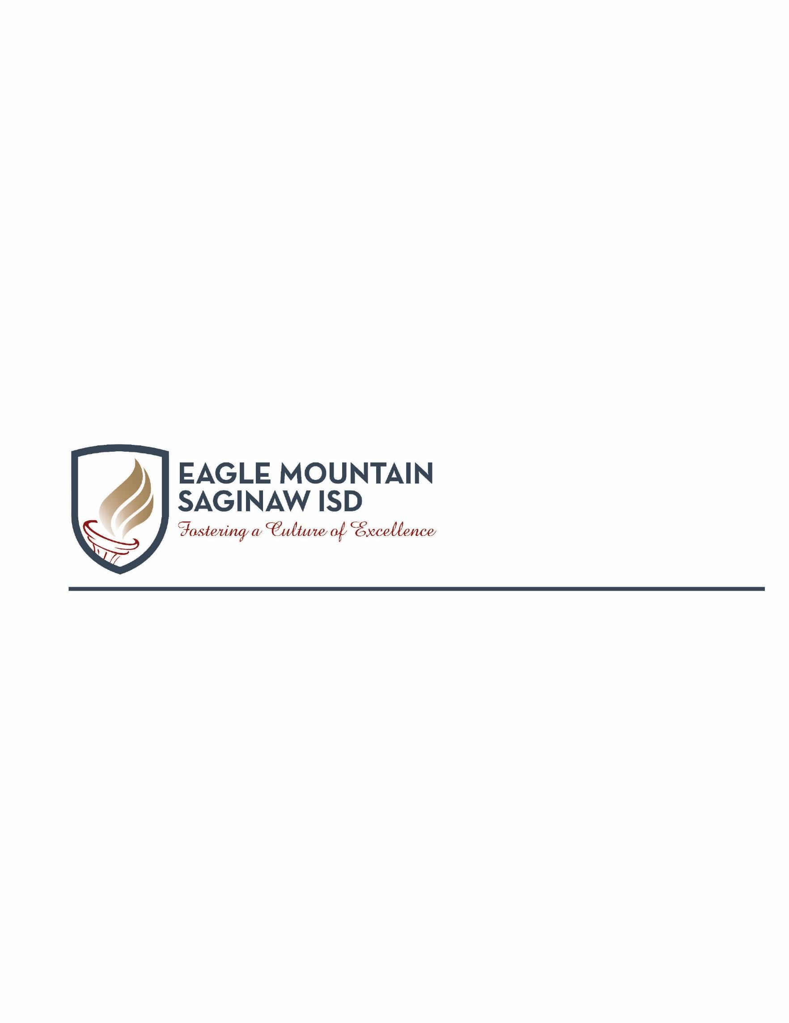

Dear Parent/Guardian,

World History Studies is a survey of the history of humankind. Due to the expanse of world history and the time limitations of the school year, the scope of this course focuses on "essential" concepts and skills that can be applied to various eras, events, and people. The major emphasis is on the study of significant people, events, and issues from the earliest times to the present. Traditional historical points of reference in world history are identified as students analyze important events and issues in western civilization as well as in civilizations in other parts of the world. Students evaluate the causes and effects of political and economic imperialism and of major political revolutions since the 17th century. Students examine the impact of geographic factors on major historic events and identify the historic origins of contemporary economic systems. Students analyze the process by which constitutional governments evolved as well as the ideas from historic documents that influenced that process. Students trace the historical development of important legal and political concepts. Students examine the history and impact of major religious and philosophical culmination of the civic and governmental content and concepts. Students learn major political ideas and forms of government in history. A significant focus of the course is on the U.S. Constitution, its underlying principles and ideas, and the form of government it created. Students analyze major concepts of republicanism, federalism, checks and balances, separation of powers, popular sovereignty, and individual rights and compare the U.S. system of government with other political systems. Students identify the role of government in the U.S. free enterprise system and examine the strategic importance of places to the United States. Students analyze the impact of individuals, political parties, interest groups, and the media on the American political system, evaluate the importance of voluntary individual participation in a constitutional republic, and analyze the rights guaranteed by the U.S. Constitution. Students examine the relationship between governmental policies and the culture of the United States. Students identify examples of government policies that encourage scientific research and use critical-thinking skills to create a product on a contemporary government issue.

During the sixth six weeks grading period, students will be engaged in course work over the following units of study:

**Unit 6: The World Wars, The Cold War, and Globalization (1914 – Present)**

Students will know various aspects of the social, economic, and political characteristics of the modern globalized world.

Throughout the sixth six weeks grading period, student knowledge and understanding will be assessed in a variety of ways, such as:

* Thinking Maps and Graphic Organizers
* Collaborative Small and Large Group Discussions (Socratic)
* Document Analysis of Primary and Secondary Sources (Historiography)
* Analysis of Causation and Periodization
* Comparison and Contextualization
* Critical Listening and Note Taking/Summarizing
* Critical Questioning
* Historical Argumentation
* Synthesis and Historical Interpretation
* Mental Mapping – geographical awareness
* Formative and summative assessments

Please feel free to contact us if you have any questions or concerns regarding your student.

We look forward to working with you and your child to ensure academic success.

Respectfully,

World History Teachers